Subject:

Connect up multiple interpolation scripts to a scene in Unity.

Screen Shots

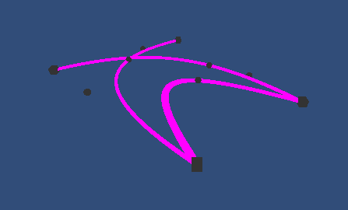

Notes

Coding is quite difficult, but I am getting there.

Task Log

Task | Date | Start | End | Interruptions | Hours
Write out problem statement | 10/5/14 | 18.45 | 19.15 |  | 0.60
Testing | 10/5/14 | 19.15 | 19.35 |  | 0.24
Submit to source control | 10/5/14 | 19.35 | 19.45 |  | 0.08

